ACA Module 9 Challenge Lab

____________________________________________________

COS 20019- Cloud Computing Architecture

Nguyen Manh Dung

5/7/2023

**This is all my step to finish ACA Module 9 Challenge Lab, each screenshot include requirements and explanations.**

**Answering questions about the lab**

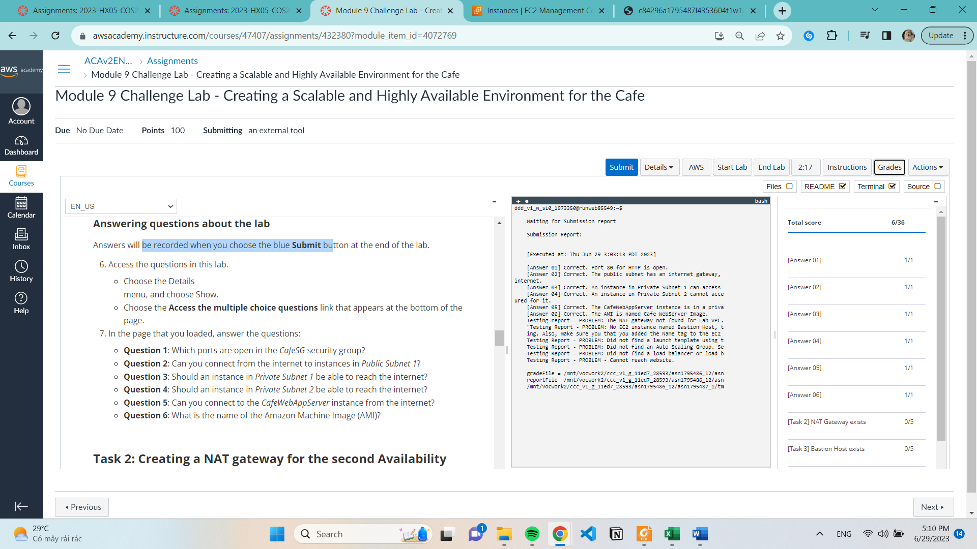

**Task 2: Creating a NAT gateway for the second Availability Zone**

**Configure the network to send internet-bound traffic from instances in Private Subnet 2 to the NAT gateway**

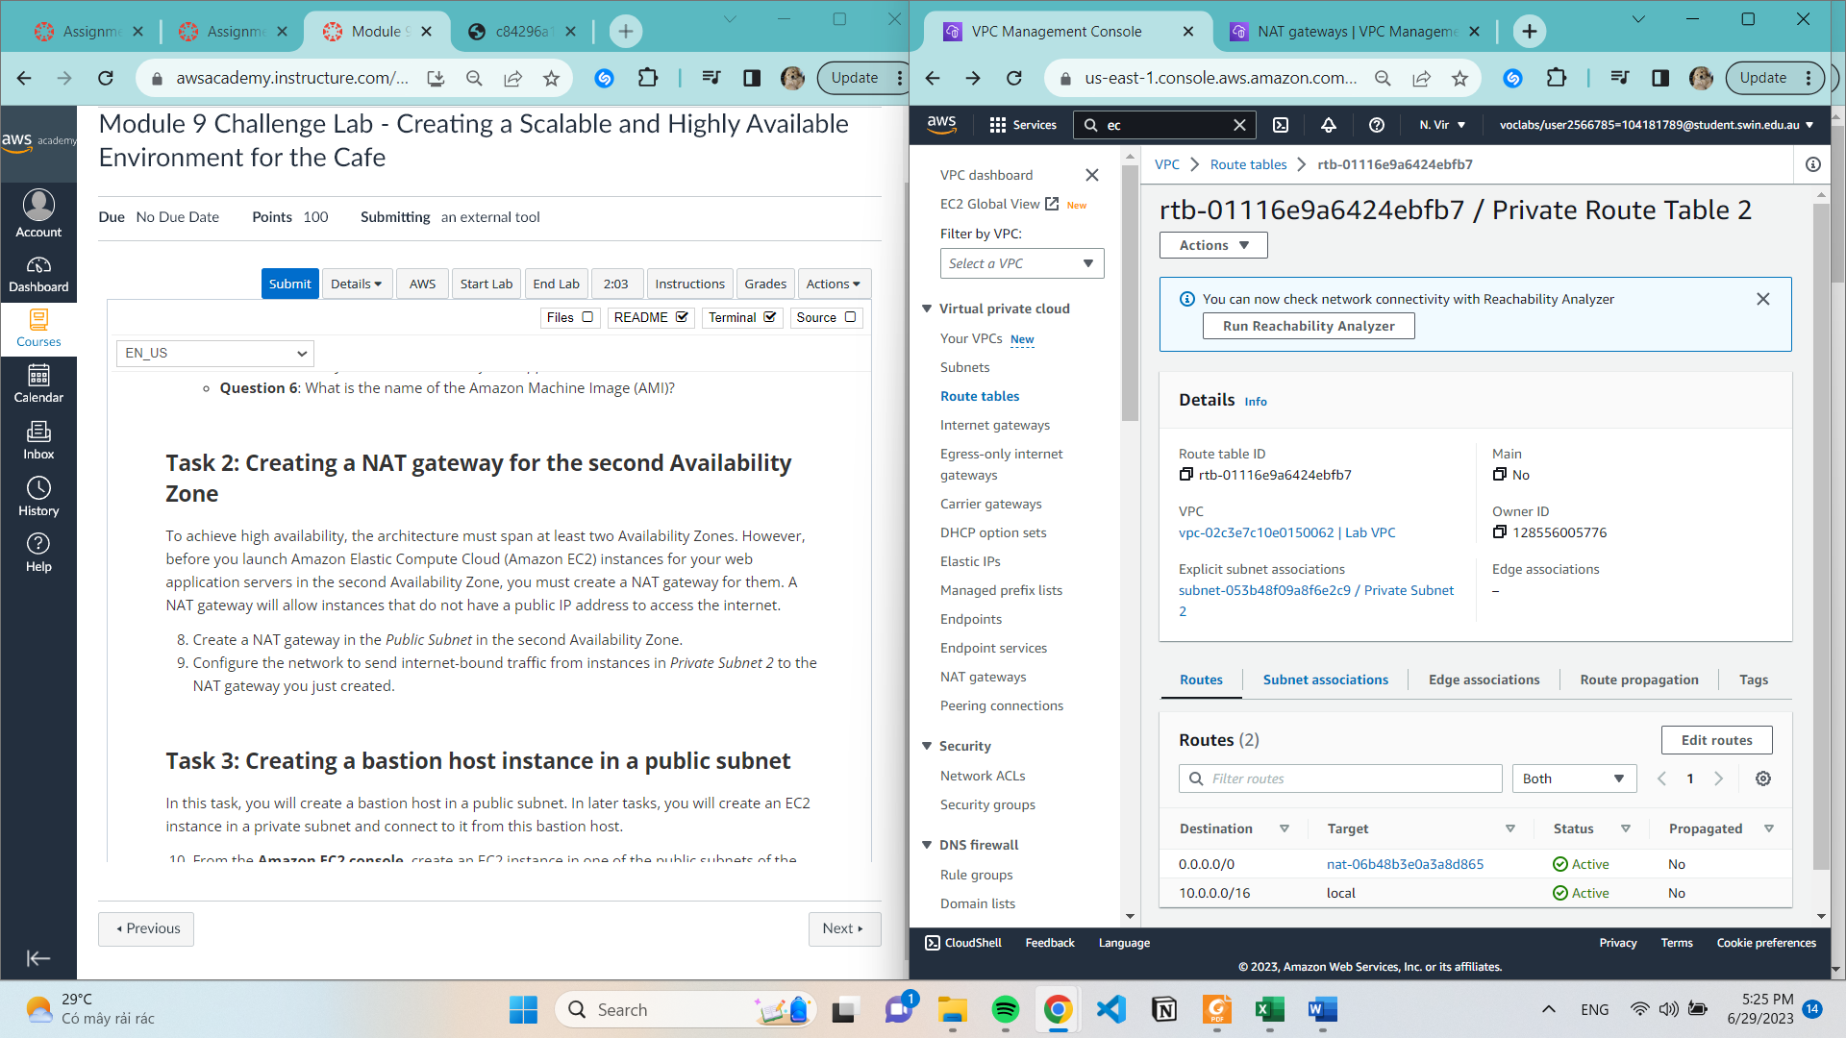

**Task 3: Creating a bastion host instance in a public subnet**

**Task 4: Creating a launch template**

**